Garrett Hurd
ECEN 3730
Board 2 Report
Project Overview:
The goal of this board is to compare good and bad design practices with identical circuit designs. Good design practices include a decoupling capacitor close to the IC, short traces, and a return plane. Bad design practices include a decoupling capacitor far from the IC, long traces, and not having a return plane. To see how the effects of good and bad design practices, we will compare the rise and fall times of each design and take note of the differences.
Below is the block diagram I wrote for this board followed by schematic and board layout in Altium.
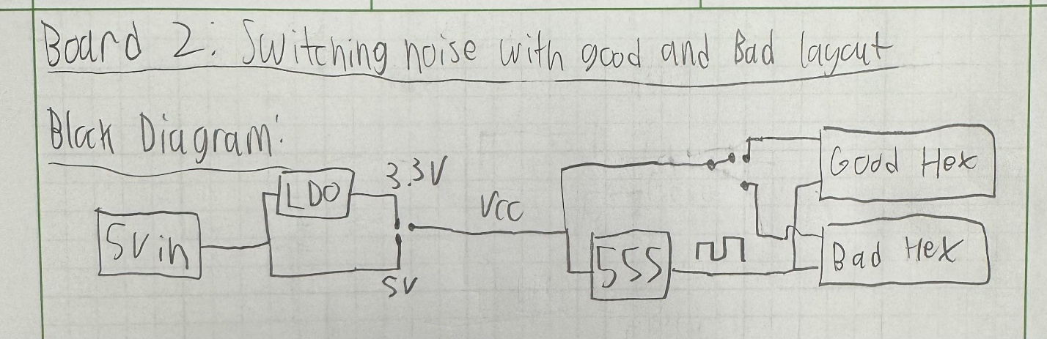
Fig. 1: Block Diagram of Board 2

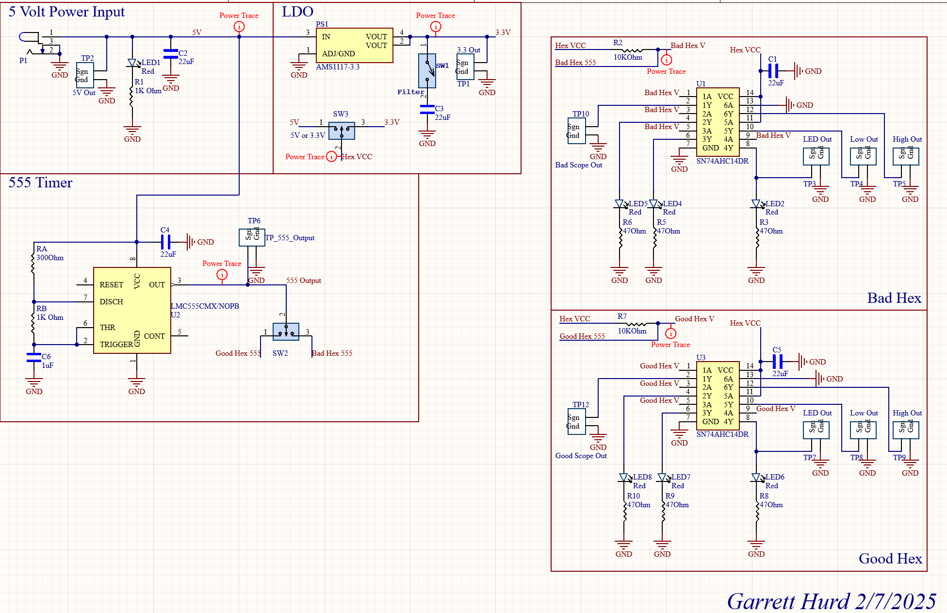
Fig. 2: Altium Schematic
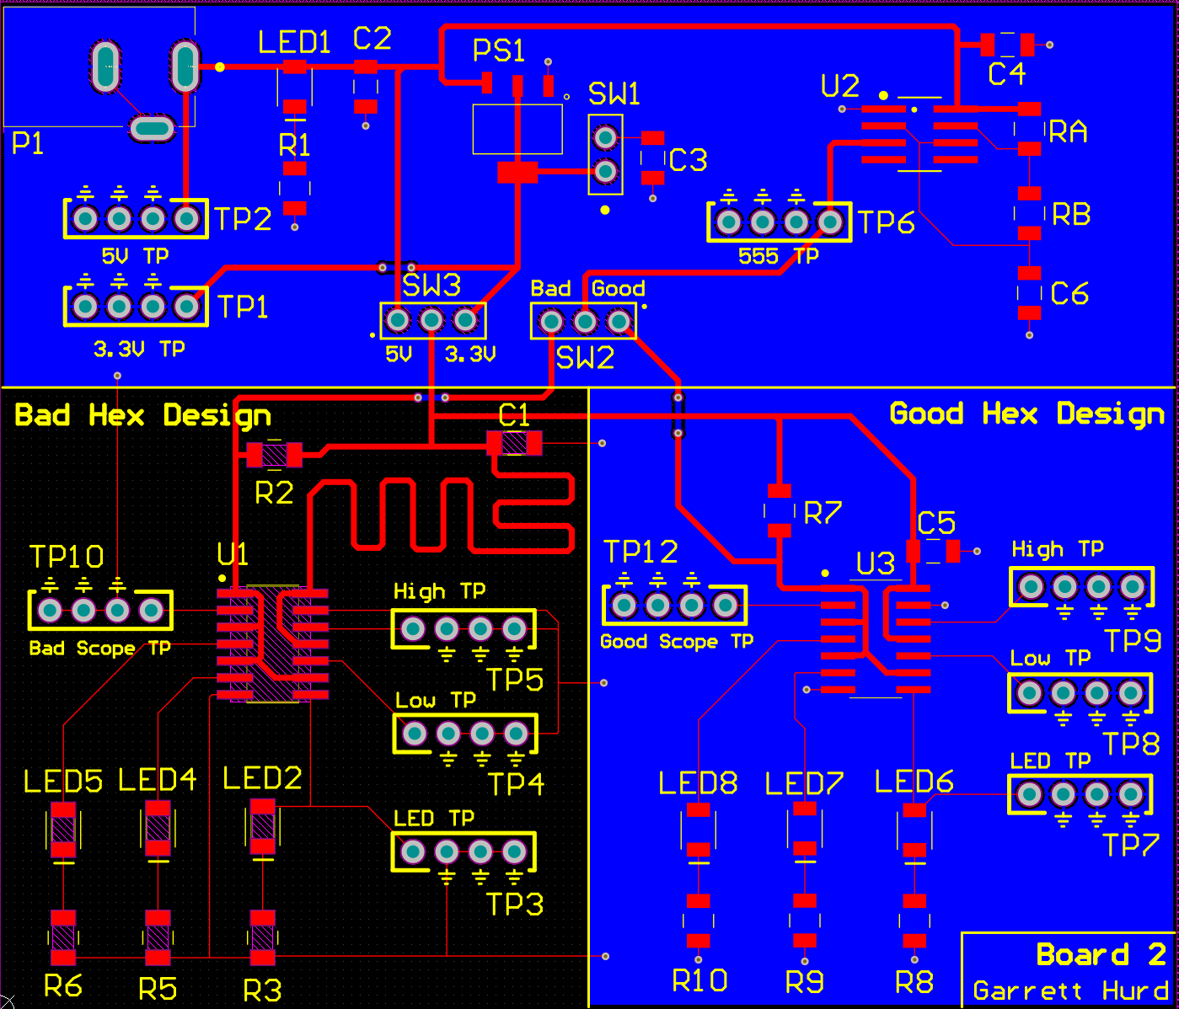
Fig. 3: PCB Layout in Altium

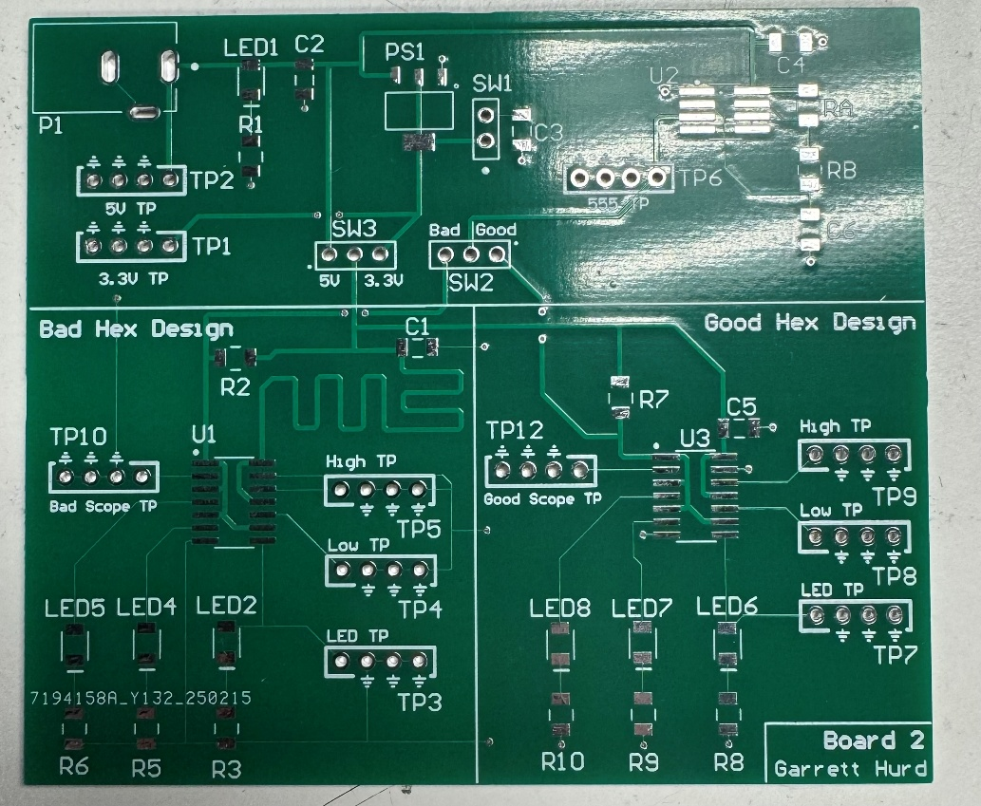
Fig. 4: Physical Board
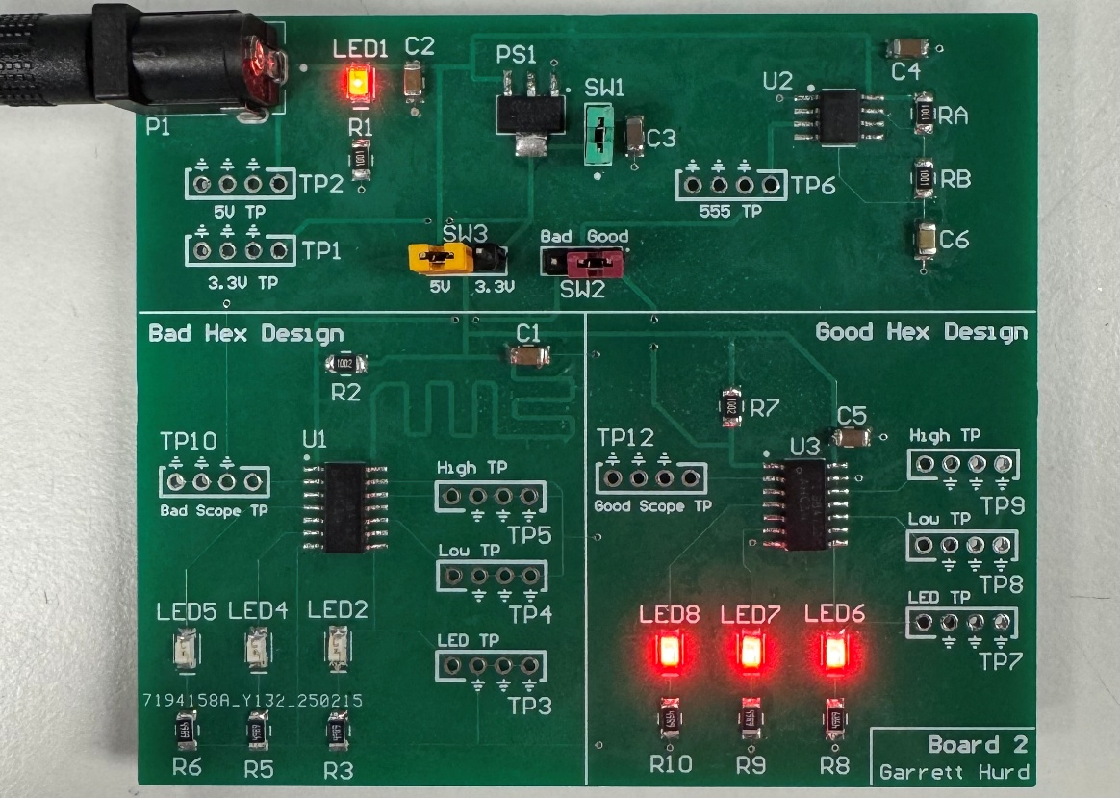
Fig. 5: Board soldered and powered up
What worked:
Before we determine the difference between good and bad design practices, I need to confirm that my timer circuit is working. This timer circuit is the same from board 1, astable mode, duty cycle of about 50%, and frequency of about 500 Hz. I will note that I used 1k ohms for RA instead of 300 ohms.
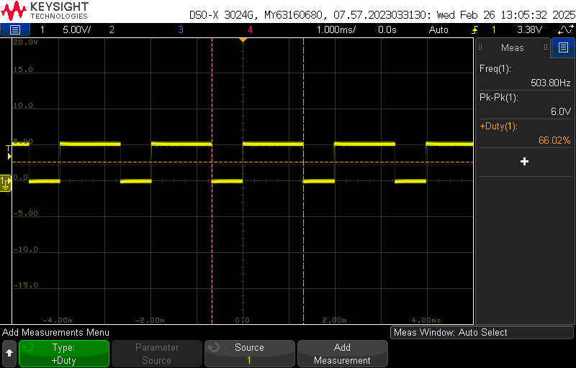
Fig. 6: 555 Timer Output
As you can see from Fig. 6, the timer circuit is working as it should based off the measurements. It is now time to continue with the analysis. First, I will analyze the good design side of the board. Channel 1 (yellow) will be probing TP12 (the scope output of the hex inverter) and channel 2 (green) will be used to probe TP9 and TP8 (High and low output of the hex, respectively)

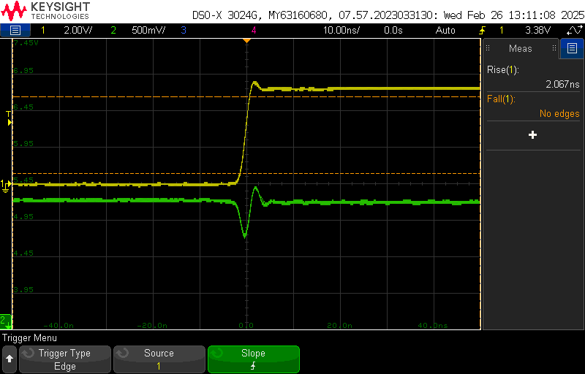
Fig. 7: Good Design High Rising Output
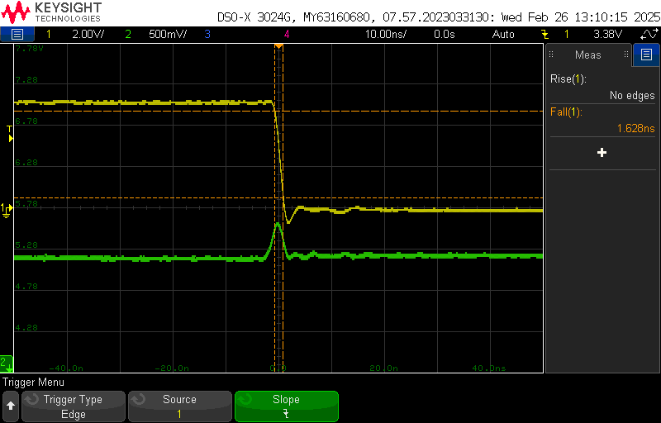
Fig. 8: Good Design High Falling Output

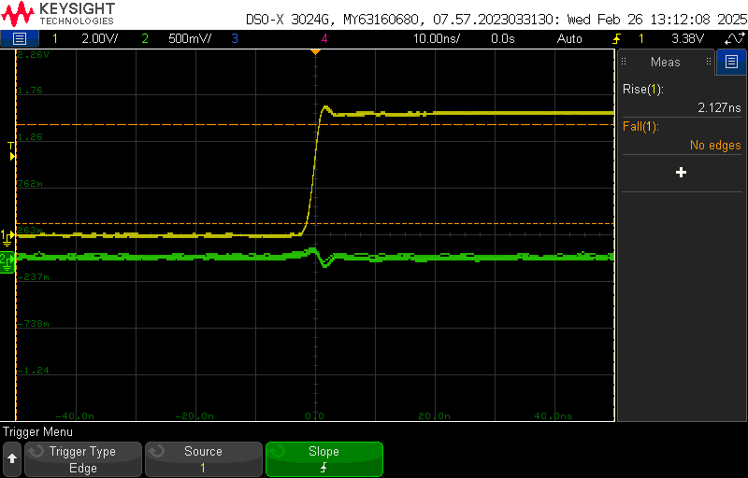
Fig. 9: Good Design Low Rising Output
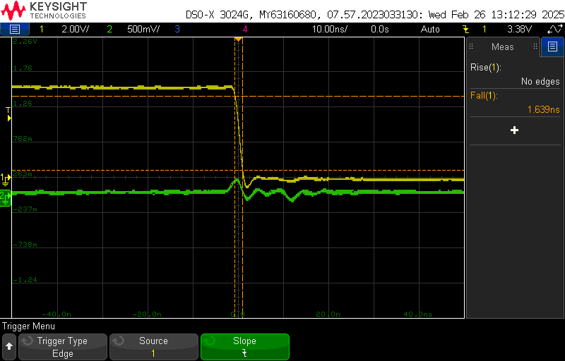
Fig. 10: Good Design Low Falling Output
Based on above, by having a decouple capacitor near the hex inverter and having a return plane (i.e. good design practices) there is little to no noise on both the high and low outputs on hex inverter. With this in mind, let’s take a look at the same outputs but with bad design practices.

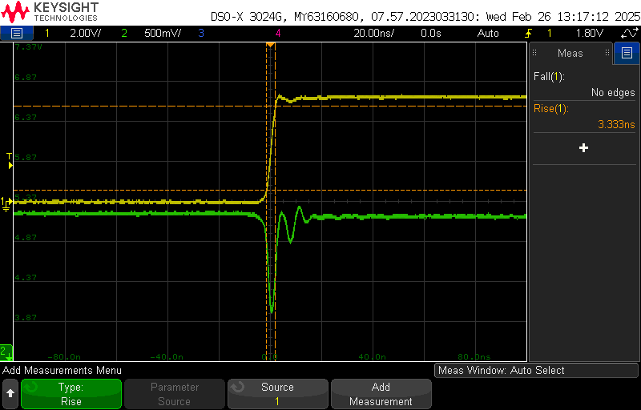
Fig. 11: Bad Design High Rising Output

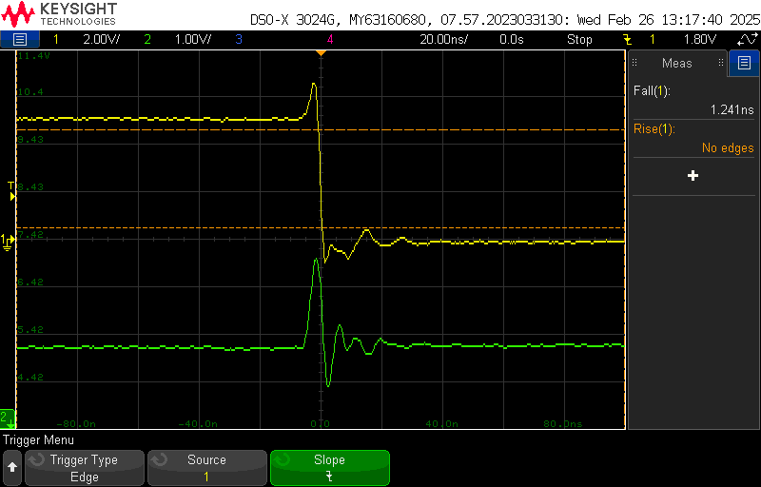
Fig. 12: Bad Design High Falling Output

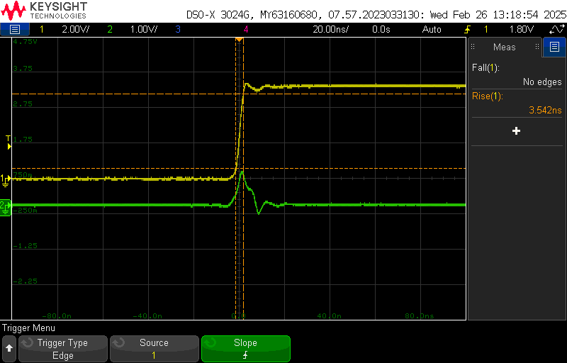
Fig. 13: Bad Design Low Rising Output

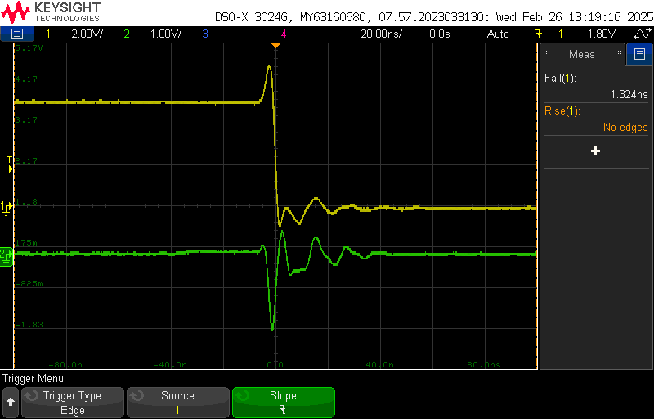
Fig. 14: Bad Design Low Falling Output

As you tell see from the scopes above, having bad design practices has a major effect on signal integrity of the circuit. There is significantly more noise in both the high and low outputs compared to the good design practice. There is also an increase in both rise and fall times with the bad design practice.
Based off all the scope shots, my board is working as intended to demonstrate the difference between good and bad design practices.

Analysis of the project:
Using the scope shots above, we can determine how much of an impact bad design practices have on identical circuits. To do this, I will compare the rise and fall times of both the high and low outputs of the hex inverters.
High Output | Rising Time | Falling Time
Good Design | 2.067 ns | 1.628 ns
Bad Design | 3.333 ns | 1.241 ns
Difference | 1.61x slower | 0.762x slower

Low Output | Rising Time | Falling Time
Good Design | 2.127 ns | 1.639 ns
Bad Design | 3.542 ns | 1.324 ns
Difference | 1.67x slower | 0.808x slower

As you can see from my calculations, bad design practices have an effect on the performance of the circuit. Therefore, it is important to incorporate good design practices into all circuit designs to ensure that the performance and signal integrity are at the best they can be.

For this board, I analyzed the performance impact of bad circuit design practices and good circuit design practices on identical circuit layouts. You can reduce noise and improve performance just by simply adding a decoupling capacitor and having a return plane to your board design.
Also, for this board, I took the experience I learned from my last board and applied it here. I routed my traces and placed circuit elements a lot better this time around. I also learned how powerful and useful net labels are Altium.
For hard errors, I had an issue with SW2. This switch is used so that I can switch the output of the 555 timer to the good hex design side and the bad hex design side. Sometimes, both sides would have their LEDs on and other times it would work as intended. I believe this is a soldering issue with switch, in future designs I will be extra careful with soldering elements to my boards. No soft errors to report.
Overall, this board taught me basic and powerful design principles that I will use for all my future boards moving forward.

